**Lab Assignment 6**

This is an android application which has a Login page and an api which converts text to speech.

**Wire Frames:**

**Sign Up Page:**

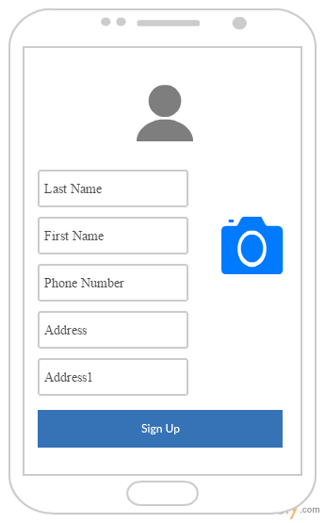

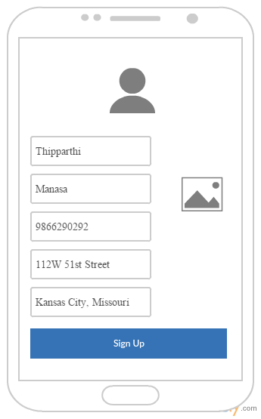

**Map Page:**

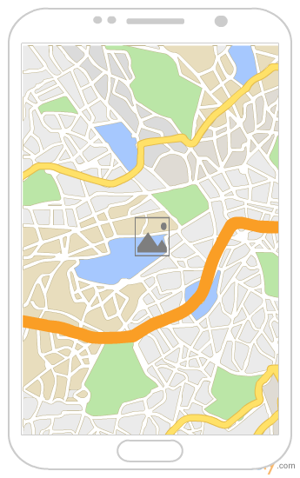

**Android Application Pages:**

**Sign Up Page:**

This sign up page contains First name, last name, Phone number and Address fields. The Address gets populated automatically when the screen loads based on the location. On Clicking on the camera button camera will be opened and we can capture the photo. After capturing the photo it will be displayed in the place of camera button. On clicking on the sign in button it will navigate to the Map page.

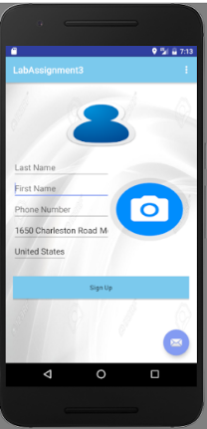

**Map Page:**

This page displays a map with the current location of the user and displays the image captured in the signup page in the current location.